**Ampli Biochemistry Kit: Advanced Level**

**Today we will be experimenting with several things:**

* Designing Ampli circuits for modular flow chemistry
* Constructing a linear chemical reaction with various elements to create nylon polymers
* Characterizing the yeast->ethanol bioreactor and production efficiency
* Utilizing the ethanol product in organic synthesis reactions

**Materials**

Check that you have all of the following:

* Ampli bioreactor with fermenting yeast culture
* Set of Ampli blocks
* Forceps
* Plastic pipette droppers
* Hot Hands warming pad
* Food coloring
* pH strips and urinalysis strips
* Lab coat and gloves
* Your teacher will supply methanol and ethanol if needed
* Your classroom will have color sensors, SensorTags, and multimeters to share

**Safety**

In our activities today we will be working with real chemical reagents, the same as those used in organic chemistry labs. Some may be flammable, corrosive, or toxic when in concentrated form. Our chemicals are inside the blocks, so do not require the protective equipment used in a traditional laboratory setting, but they should be handled with care. When doing the Nylon Synthesis and Ampli Organic Chemistry activities, don’t take apart any blocks (and ask a teacher for help if they come apart by accident), don’t connect chemical blocks in ways other than directed, and don’t heat any blocks unless instructed to do so. If you ever see anything unexpected, weird, or confusing with your chemical blocks, ask a teacher to evaluate it. And make sure to always be wearing your lab coat and gloves!

Teacher Notes: Safety protocols are very important for these activities, because although the chemicals are in small quantities and behind acrylic lids, they are reactive and several are fairly toxic when handled normally. Students should take glove-wearing seriously, and there shouldn’t be any direct smelling of chemical blocks, etc… In addition, if any lids come off, make sure that a teacher checks that they get put back on properly.

Some of the chemicals should not be mixed together, like acid with PCC, PCC and KMNO4 -- in general, try to prevent blocks being ordered differently than instructed, and store prepared and used blocks like with like to prevent unintended reactions.

Oxidizers such as PCC and KMNO4 are strong and reactive chemicals. If anything ever heats up, behaves reactively and unexpectedly, or anything else, move the block to water immediately or douse with water if you feel unable to move it. All of these reactions have been tested and deemed quite safe, but in the off chance that anything unexpected happens, water is an effective solution that won’t exacerbate anything.

**1. Introduction to Ampli**

Take a look at your Ampli blocks. They each have paper for flowing fluids inside, and interlocking frames like puzzle pieces. Design a circuit with 5 blocks, and flow food coloring through it. What directions does flow occur? What pathways can you create?

Discussion Questions:

* In what ways does this system differ from traditional laboratory chemistry? How might this system be uniquely useful?

Teacher Notes: Students can use a combination of food coloring and salicylic acid to lower pH in the same circuit. Remind them they can turn corners, and that flow can start on two ends, and meet in the center! Have them describe and get used to the flow pattern and timing on paper.

Handling pH strips: The pH strips may already be inserted, or may not. If they are not, you can do one of two things -- Carefully remove the lid of the desired block (this should be plenty safe) and lay the pH strip face up on the block on top of the paper, allowing flow to occur. Or, more guaranteed to work well, simply remove the lid when you are ready to test, and press the pH strip face down on the block paper, letting it absorb the liquid from the paper and test. You can simply dip pH and urinalysis papers into the bioreactor, being careful not to disturb the yeast too much.

**2. Nylon Synthesis**

One of the things we can do with Ampli blocks is chemistry! Your teacher will tell you about polymers and how to create them. A common polymer you might find in your clothing, shoes, toothbrushes, guitar strings, and more is nylon. We can make it today!

Teacher Notes: Polymers are long chains of molecules which bind together under certain conditions to form macromolecules -- often visible to the eye. There are lots of natural polymers, such as polysaccharides (they are long chain sugars that make starches, like grains, potatoes, and corn) and even DNA (with lots of chained bases). There are also lots of synthetic, human-made polymers, which have special useful properties.

Lots of synthetic plastic-type materials are polymers, and have useful properties that most monomeric molecules do not. Think about polyethelyne, PVC, and nylon (which we will make today!). They all have unusual properties like tensile strength, elasticity, or non-reactivity. Many monomers require a catalyst to begin the chaining process, such as heat or specific-wavelength light.

Connect your nylon reaction blocks together on your red Ampli board like this:

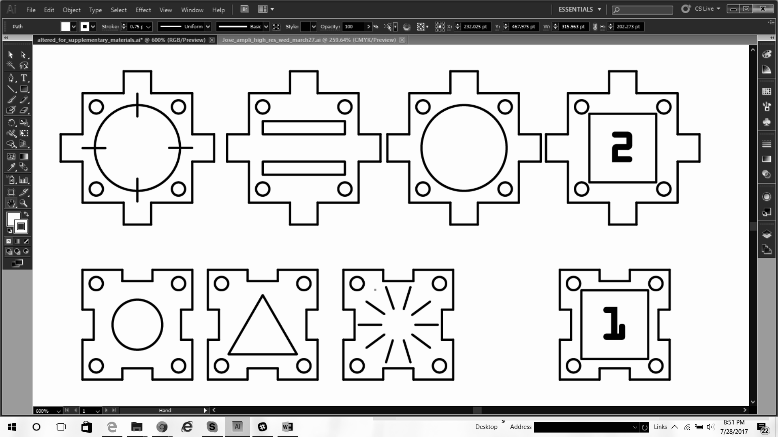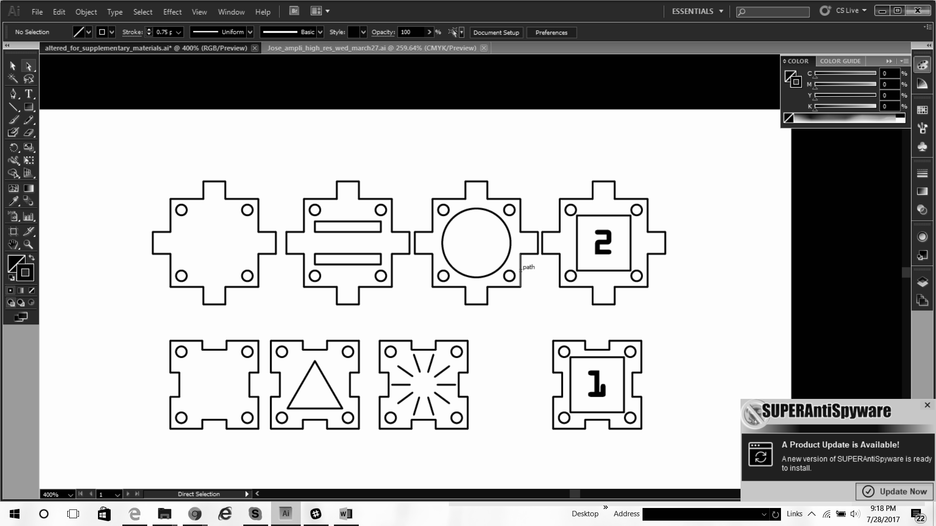

**Don’t forget to wear gloves and a lab coat!**

When you are certain that the blocks are assembled correctly, ask your teacher for some methanol. Pipette the methanol into the open pipette block a little at a time, and watch it flow through the system. When it reaches the last block, stop pipetting! Open a Hot Hands packet, shake to start the warming process, and lay it carefully over the entire chain of blocks. Leave it to incubate for at least 30 minutes -- you can come back and check on it at the end of the Ampli Organic Chemistry activity! Make sure your blocks stay wet during this time period. You may need to pipette a little more methanol into the system every 10 minutes or so.

When at least 30 minutes have passed, remove the heat pack and connect the color change blocks like this:

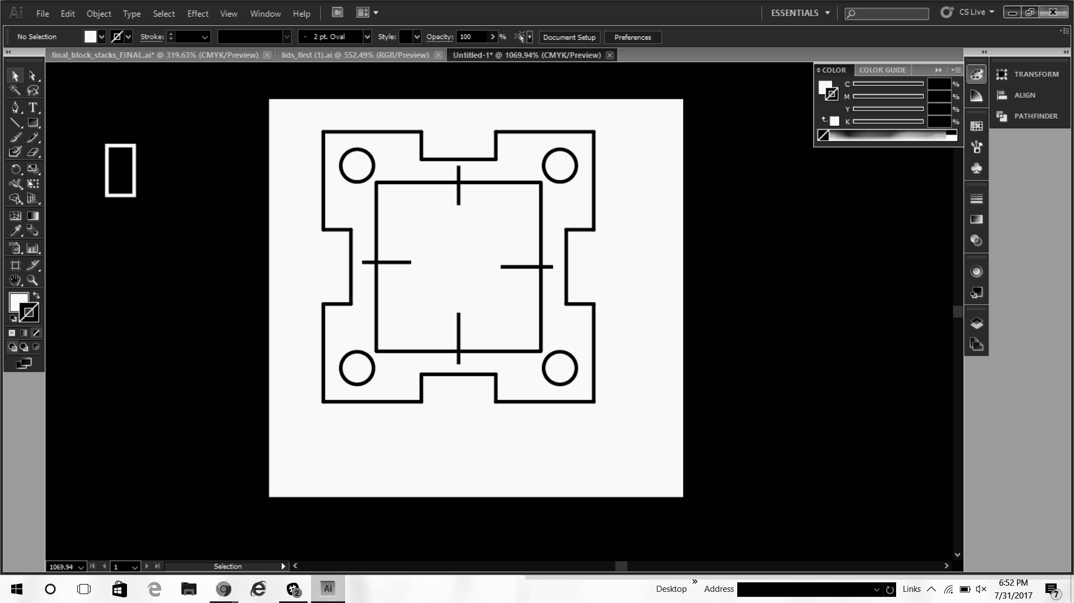

Teacher Notes: Gold nanoparticles are formed when Gold III Chloride interacts with HEPES (4-(2-hydroxyethyl)-1-piperazineethanesulfonic acid), something called a Good’s Buffer. The gold forms special tiny structures, which have unusual properties with respect to light, electricity, and chemical reactivity. They have many uses in therapeutics, diagnostics, sensors, electronics, and more.

Gold nanoparticles love to bind and “stick” to things, because they have lots of binding sites all over their surfaces. They stick to the nylon, giving it the faint gold color you see in the last block!

Flow some water through the system by pipetting into the pipette block, the same as you did with methanol. This will wash the nylon polymer chains into the nanoparticle block, where they will bind with gold nanoparticles. Keep a close eye on the last block of the system -- as the nylon flows into it, you should see a slight yellow color. This is the gold nylon you just made!

Discussion questions:

* What other kinds of things are polymers? What would be a useful polymer to make with an Ampli kit?
* Can you see the nylon fibers? Why do you think you can or can’t?
* Can you come up with any properties of nylon polymers that you might be able to test?

Teacher Notes: Common pitfalls with the nylon reaction include flow issues and evaporation, and heating issues. To avoid heating issues, make sure the hot pack has been shaken thoroughly but carefully to expose as much of the internal heating sand as possible to air. You can check the temperature or the temperature of the blocks with a surface thermometer if available, ideally they should reach over 100 degrees Farenheit. To avoid flow issues, keep a close eye on flow and evaporation in the system. Methanol evaporates extremely swiftly, like most alcohols, and you will probably have to pipette more very regularly during the incubation. If you don’t see a good color change in the gold nylon block, try incubating longer, pipetting more methanol, or pipetting some water through to mix the nylon monomers better.

**3. Ampli Organic Chemistry**

Teacher Notes: Fermentation in general is a process that converts sugars to acids and gases and produces usable energy from nutrients. Every organism has a process like this, known as cellular respiration, which is very efficient and requires sugar and oxygen. Many organisms, including yeast, bacteria, and humans, also have an alternate energy production pathway -- the fermentation pathway kicks in for energy production and use of sugars when a key reactant required for normal cellular respiration is unavailable. Most commonly this missing reactant is oxygen; for instance, in humans if you exercise too much and your muscle cells do not get enough oxygen, the muscle cells go through lactic acid fermentation and produce lactic acid: the chemical that makes your muscles sore after you exercise a lot!

In yeast, fermentation is very useful in the food industry, because it takes sugars and converts them to ethanol and carbon dioxide gas. If you put yeast in bread dough, the oxygen supply is limited and it uses fermentation to break down sugars, resulting in lots of carbon dioxide that makes bread bubbly and fluffy rather than flat like unleavened bread. If you let yeast ferment various other fruits and grains, you can use the ethanol to create alcoholic drinks.

Fermentation happens when yeast are warm enough to grow with nutrients, but oxygen deprived, and with lots of sugar to break down. It produces carbon dioxide gas and ethanol (and some amounts of methanol as well, which is just one reason you shouldn’t drink the bioreactors -- methanol is purified out of alcoholic beverages but is poisonous to humans).

We suggest the students test the glucose content of both a fermenting bioreactor and a non-fermenting bioreactor. The fermenting one, if it’s been working long enough, should have less or even no sugar left! The non-fermenting one should have had the original amount of sugar added to simulate the fermenting bioreactor before incubation. Consider also pH -- yeast, like the majority of living organisms (though not all! Some rare organisms are adapted for survival in crazy conditions like extremely high temperatures, extreme chemical environments, and extremely acidic environments) likes a pH of somewhere around 7 best. Yeast won’t make substances with unfriendly pH on its own, but contamination and other processes during fermentation *can* sometimes cause the pH to fluctuate. If you see a major difference in pH between bioreactors, there may be some interesting environmental effects happening.

Another thing we can do with Ampli blocks is bioprocessing. Your teacher will tell you about bioreactors, ethanol production, and downstream processing. One of the most useful ways to process ethanol is to perform organic synthesis -- the process of chemically adding or removing a set of molecules from a structure in order to create an entirely new substance. In this case, we will use ethanol two ways: to form acetaldehyde and acetic acid (also known as very strong vinegar)!

Teacher Notes: For the purposes of comprehension in this class, try focusing on organic synthesis as a way of exchanging, altering, adding, or removing “functional groups” on molecules. Each functional group, a set of atoms that can add to carbon structures, has its own set of properties -- charge, reactivity, even things such as characteristic smell or appearance. In this way organic chemistry is like a highly modular, highly complex molecule building system!

We are adding carbon-oxygen bonds to get the products we get today (oxidation). Acetaldehyde, an Aldehyde functional group, is formed when one C-O bond is added to Ethanol, but it is unstable in the presence of water and will oxidize to Acetic Acid, a Carboxylic Acid functional group, very quickly. So to prevent this oxidation from continuing, we use PCC, a reagent specialized to function in anhydrous (no water) environments. This keeps the reaction from proceeding all the way, and gives us Acetaldehyde. (Yes, some water will travel down from the bioreactor. This will cause some side product Acetic Acid, but PCC and the anhydrous solvent will help to keep the major product Acetaldehyde.) To make the carboxylic acid Acetic Acid, we just use a strong oxidizing agent, potassium permanganate, and add water to let it continue!

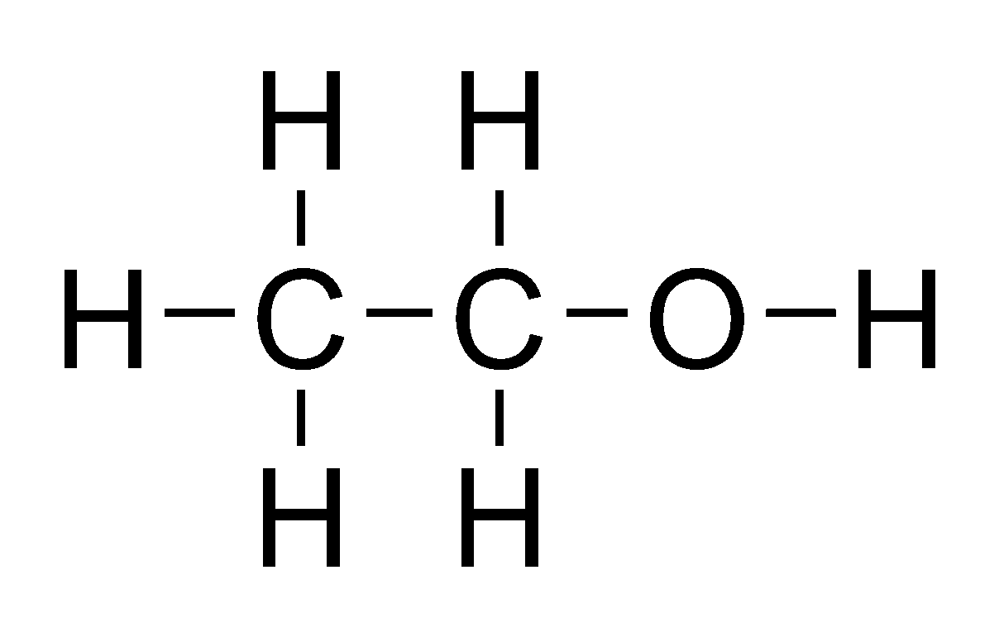 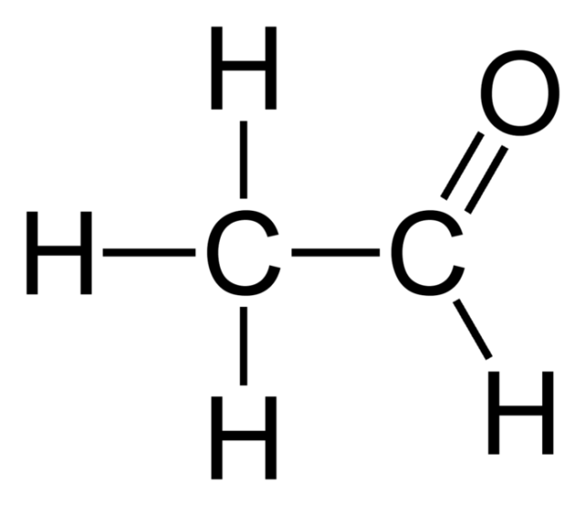 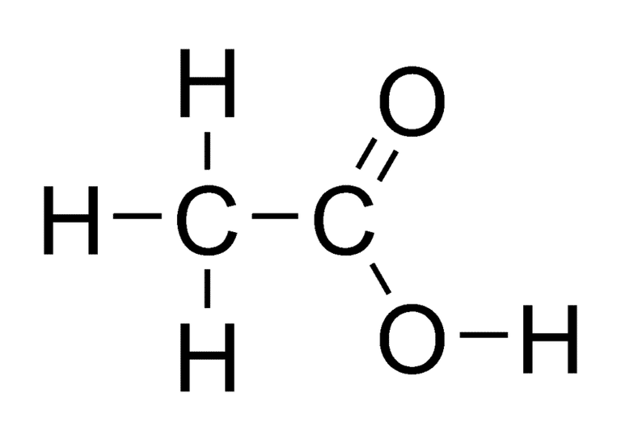

Ethanol Acetaldehyde Acetic Acid

Before we get started, check your bioreactor to see if the yeast are producing enough ethanol to be used for synthesis.

* Remove the lid of the bioreactor and use the urinalysis strips to test the sugar (glucose) content of your yeast media. Compare to your teacher’s bioreactor. Since yours is undergoing fermentation, it should have less sugar. If it doesn’t, that may be an indication that your yeast has not produced enough ethanol yet.
* Dip a metal fork, glass rod, or similar into the bioreactor, taking care to only touch the clear supernatant fluid and not the soft, yellow-white yeast. With your teacher’s supervision, pass the fork through the top of a flame. You should see the ethanol burning off the fork! If you don’t see flames on the fork, this may be an indication that your yeast has not produced enough ethanol yet.

If you think your bioreactor may not have much ethanol content, get some pure ethanol from your teacher and pour a few mL into the bioreactor to use instead.

Teacher Notes: If you find your class is having consistently poor results with finding ethanol, there are several things that may be going wrong. It may be, especially on Tuesday, that the bioreactors simply need to incubate longer at the temperature they have been kept at. You could transfer them somewhere slightly warmer, or simply wrap them and leave them be for another night. It may be that the yeast are obtaining oxygen -- check that the plastic wrap is forming a relatively close seal (it doesn’t need to be perfect, but no major breezes). It may also be, especially later in the week, that the yeast may have run out of sugar to process. Try adding some more sugar to the bioreactor every other day. It may also be that the pH of the bioreactor has been changed and the yeast are not healthy -- check the pH, and try adding a mild base or acid to adjust close to pH 7. Also later in the week, the yeast may have too much ethanol -- this shouldn’t be a huge issue for class, but if the yeast seem to be diminishing in density or smell, try removing some of the ethanol supernatant and/or adding water.

In any case, if your class feels they do not have enough ethanol to work with, pour about 2mL pure ethanol (a relatively pure drinking or cleaning alcohol acceptable if no other option) into the bioreactor for use during class. Be aware that this is not particularly good for the yeast, so you may have to keep them warmer to recover or remove some ethanol supernatant after class.

When you have verified that your bioreactor contains ethanol, set up your chemical blocks like this and lastly, connect them to the bioreactor with a ramp!

**Don’t forget to wear gloves and a lab coat!**

Acetaldehyde:



Acetic Acid:



Give the chemicals some time to mix and flow, maybe 10-20 minutes or so. As the reactions run, there are lots of experiments you can try to monitor the progress of the reaction and verify the existence of a new chemical product.

* Watch the chemical blocks for color changes -- you may see the Potassium Permanganate block turn from dark purple to brown, and you may see the PCC block turn from orange to clear or brown. Experiment with the color sensor to see if it picks up any changes!
* Try comparing the pH block where you made acetic acid, to the pH of the bioreactor. There should be a difference! Do you predict that acetic acid will be higher or lower pH than the bioreactor?
* Use the classroom multimeters to test electrical conductivity and resistance of various blocks, particularly the block where you made acetaldehyde. Compare to the bioreactor, to your food coloring blocks, or to a drop of water on the table. What do you notice?
* What else can you test with the materials in your classroom? Be creative!

At the end of class, carefully tape a SensorTag above your bioreactor and re-wrap airtight with plastic wrap so that the yeast can continue fermentation overnight. Your teacher will show you how to turn on the SensorTag and track it online, so you can watch temperature and pressure changes as the fermentation progresses!

Teacher Notes: You can use the SensorTag with the TI SensorTag app on any bluetooth-enabled smartphone. You can leave a phone near it if possible, or track only when a phone is nearby. It can track lots of information, but we recommend looking at temperature (it should rise during fermentation) and pressure (it should also rise during fermentation as carbon dioxide gas is produced). We recommend setting the SensorTag in its silicone case on top of the bridges of the bioreactor so that it won’t fall in, and wrapping the whole enclosure carefully with plastic wrap to hold it in place.

Discussion Questions:

* What do you know about the properties of ethanol, acetaldehyde, and acetic acid? Can you think of other properties you might be able to test with other materials?
* You are actually very familiar with acetic acid -- a very dilute version is called vinegar. What did you learn about its properties today? Does that explain anything about the taste of vinegar, or the disinfectant and odor-removal properties of vinegar?
* Was there anything that didn’t turn out as you expected? Can you think of anything (errors, protocol changes, environmental factors, and more) which might have affected this? Can you think of changes you might want to implement to make these reactions more efficient or effective?
* What did you learn today? What are you going to research or investigate more in the future

Teacher Notes: At the end of class, make sure that the student bioreactors are sealed with plastic wrap, and any that you might want to keep a SensorTag on have one and it is connected to an app on a nearby device. You may want to keep the non-fermenting bioreactor unwrapped, or you could wrap it and allow it to ferment and inoculate a new non-fermenting bioreactor for the next day.

To inoculate, fill growth media tube with water (preferably sterile dH20 or bottled water, but tap water would also work). Shake until mixed, pour into bioreactor, and add about 2mL (height in the tube) of dry yeast to the bioreactor. Keep in a decently warm place (not near AC’s or in fridges, room temperature is okay) for 8-12 hours. Then, to start fermentation, add about a tablespoon of sugar (table sugar or lab glucose) and wrap with plastic wrap to seal in a low-oxygen environment. Keep in a decently warm place again for 8-12 hours.

If you wish to clean the Ampli blocks yourself:

**It is preferable to do this in a lab or classroom setting with proper chemical disposal containers and a designated sink. Wear gloves and a lab coat.

Remove papers from blocks with tweezers, and if possible soak in water to dilute the chemicals and lower the risk of interaction with environment after disposal. Dispose of water and papers in an appropriate chemical disposal (not a regular sink). If you are unable to access a chemical disposal immediately, don’t soak the papers, simply remove them and store them in sealed plastic bags, like papers together (e.g. PCC with PCC, KMNO4 with KMNO4), until you are able to access a proper chemical disposal.   
The salicylic acid block alone is safe to dispose of in a regular trash. Yeast and media is also safe to dispose of in a regular trash or sink.

Place blocks themselves in a bottle or bowl, add dish soap or all-purpose cleaner, and (over a chemical-safe sink) run water into the container, allowing the blocks to slosh around (like a homemade dishwasher or laundry machine). If available, spraying the blocks down with ethanol or isopropanol spray will help to remove things that don’t remove easily with water. *Please note, the PCC blocks may not come clean, PCC leaves a very strong residue. Don’t worry too much about this, you can just use those blocks only for PCC.* It’s okay to mix blocks together for this wash step! There’s very little chemical on them and a lot of water.

The bioreactors can be rinsed and cleaned with soap and water without any special concerns.